III. Loving Our Neighbors in a World of Gender Confusion

A. Adopt a Posture of Compassion

B. Speak the Truth in Love

- Express love to the person
- Be quick to listen and ask open ended questions
- Explain the Biblical truth gently
- Clarify that you too are a sinner in need of grace
- Share the hope of the gospel of Christ
- Talk about details such as what language you’ll use
- Discuss what the relationship should look like

C. Offer the Supreme Hope of the Gospel

D. Call to Realistic Repentance

- Repentance is hard and possible!

- Avoid false promises about the Christian life

E. Keep Going by God’s Grace

For further study:
- Transsexualism: Issues and Argument, Oliver O’Donovan (Grove Books, 1982)
- “Transgenderism: A Theological Perspective,” Tim Scheiderer, online at The Gospel Coalition
- “Joan or John?” Russell Moore, online at the Gospel Coalition
- “Transgender Identity: Wishing Away God’s Design,” Owen Strachan, online at Answers in Genesis
- “I Was a Transgender Woman,” Walt Heyer; and “The Absurdity of Transgenderism,” Calrlos Flores, both online at The Witherspoon Institute
- “Resolution: On Transgender Identity,” 2014, Southern Baptist Convention

Questions/comments? Brad.Wheeler@capbap.org & Matt.Merker@capbap.org

Capitol Hill Baptist Church – May 15, 2016

Biblical Manhood and Womanhood – Lesson 12

Gender Confusion

I. Introduction

- “The Transgender Tipping Point”

- Showing compassion = speaking the truth in love

II. A Biblical Theology of Gender

A. God created male and female in his own image.

- Genesis 1:27-28,31 So God created man in his own image, in the image of God he created him; male and female he created them.... And God saw everything that he had made, and behold, it was very good.

- Genesis 2:24-25 Therefore a man shall leave his father and mother and hold fast to his wife, and they shall become one flesh. And the man and his wife were both naked and were not ashamed.

- Biological sex is a good gift of God to every individual. (Psalm 139:13-14)

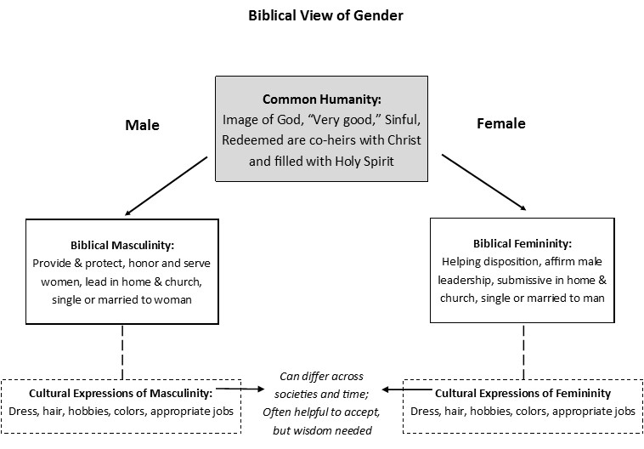

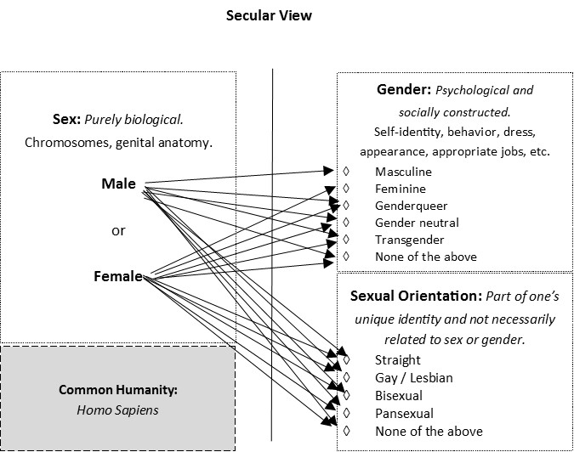
B. The fall has corrupted us in body and mind.

- Romans 1:18, 21 ... who by their unrighteousness suppress the truth... they became futile in their thinking, and their foolish hearts were darkened.

- Jeremiah 17:9 The heart is deceitful above all things, and desperately sick; who can understand it?

- The reality of fallen self-perception

- Our hope? Titus 3:3-4 For we ourselves were once foolish, disobedient, led astray.... But when the goodness and loving kindness of God our Savior appeared, he saved us, not because of works done by us...

C. The resurrection affirms the goodness of the body.

- Transgenderism: psychological identity trumps physical anatomy (mind over matter).

- Christianity: we are united, body and soul. The body is good!

- 1 Corinthians 15:42 What is sown is perishable; what is raised is imperishable...

- We will still have our God-given gender in the New Jerusalem.

