Gender Confusion
Next time class is taught:
- Change “gay/lesbian” language in diagram to “homosexual”
- Perhaps a comment on how to handle the question of whether to use a person’s new name or old name – what should you be considering here?
- A couple of sentences dealing with people who need to carry out policies at work that they can’t agree with.

I. Introduction
“By the time Coy Mathis was four years old, he knew one thing was for sure: that he wasn’t a boy.” That’s the opening statement from a recent Rolling Stone article about a child in Colorado who was convinced that his physical body didn’t match his true identity. His parents were confused at first, but over time they accepted Coy’s professed gender. They filled Coy’s closet with pink dresses and got involved in a legal battle with Coy’s elementary school over Coy’s right under Colorado state law to use the girl’s restroom.
Stories like this are commonplace now. There are an estimated 700,000 people in the US who identify as transgender: that is, they claim a gender identity different from “the sex they were assigned at birth.” Just this week we’ve seen another legal showdown, in NC, about transgender access to bathrooms. And on Friday the Department of Education issued a “Dear Colleague” letter stating that “a school must treat students consistent with their gender identity even if their education records or identification documents indicate a different sex.”
We raise the topic of gender confusion today not out of fear or surprise at such stories. We raise it in a desire to understand the beauty and goodness of how God has made us and to show compassion to our neighbors by speaking the truth in love. The issue of gender confusion isn’t just something we read about in the news – it’s something many of us face personally with relatives, friends, and colleagues we love. There are sincere godly believers who have felt discomfort or confusion about their God-given gender. So this morning we want to do two main things: explore a biblical theology of gender, and then consider some practical implications about how to love those we know who are experiencing gender confusion. I’m not going to comment so much on laws or policies – rather we want to go deeper and think theologically about how God has made us. Another note as we begin: today we’re not primarily talking about homosexuality, though that’s certainly a related issue. There are lots of biblical texts that speak directly to the sinfulness of homosexual behaviors that we won’t cover this morning. That could be a whole different class. We’re going to focus more narrowly on the question of gender identity: what it means to embrace God’s gift of being created male or female.
II. A Biblical Theology of Gender So let’s start at the beginning, with this fundamental biblical truth:
A. God created male and female in his own image and declared it very good.
Genesis 1:27-28: So God created man in his own image, in the image of God he created him; male and female he created them. And God blessed them. Verse 31: “And God saw everything that he had made, and behold, it was very good.”
We’ve already stressed in this class that men and women are equal in dignity, value and worth before God. But here it’s important to recognize that the biological differentiation between men and women is a wonderful part of our Creator’s design. God expertly crafted humanity – male and female – as the exquisite jewel of creation. We are “crowned with glory and honor” as David says in Psalm 8. God chose deliberately to exhibit his image in men and women. Men possess an awesome stewardship to display God’s fatherly care and protective, sacrificial love. Women beautifully enact for the world other aspects of what God is like: he is the helper of his people, the one who gives life, nurtures, and supports his children. Parents, when you teach your kids about what it means to be a boy or a girl, start here, with the image of God and with biblical masculinity and femininity, not cultural stereotypes.
And in Gen 2:25 we see that Adam and Eve were fully at home in their God-given, gendered bodies: “And the man and his wife were both naked and were not ashamed.” No sin. No confusion. No tension in self-understanding or identity.
So, maleness or femaleness is a gift of God to every individual. God defines it and he imparts it for our good. What David says in Psalm 139 is true of everyone: “You formed my inward parts; you knitted me together in my mother’s womb. I praise you, for I am fearfully and wonderfully made.”
I think at this point it can be helpful to take a step back and recognize how radically different this biblical view is from the way the world views sex and gender. Look at the second page of your handout. You’ll see two simple diagrams I’ve drawn up showing the differences.
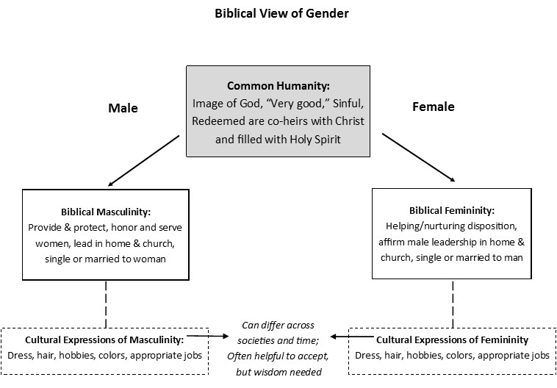
The Biblical view, on top, affirms that you are created male or female. Men and women have the most important stuff in common: that top box. They’re both created in the image of God, can find redemption in Christ, etc. On the left and right are the aspects of biblical masculinity and femininity – God given dispositions and inclinations – we’ve discussed in this class. Every man and woman has an obligation to embrace those distinct roles that are in the box. Then, at the bottom, are cultural expectations of masculinity or femininity that can vary somewhat across time and place, things like the colors blue and pink, dress, appearance, what jobs are appropriate. That stuff’s not in the Bible, generally. It will often be helpful to embrace those cultural aspects of manhood or womanhood, but that needs to be assessed with wisdom. These aspects aren’t core to being a man or a woman.
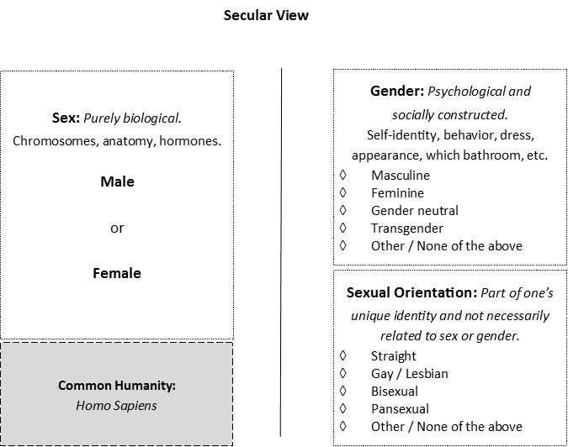
Contrast this with the secular view – not held explicitly by all in the world, but increasingly by many. In the last few decades, it’s become common for scholars to distinguish between sex and gender – thus the firm line between them in the diagram. “Sex,” they say, is biological only: you either have male or female chromosomes, anatomy and hormones. “Gender” is psychological – it pertains to your inner sense of identity. It’s socially defined and so includes things like behavior, appearance, clothing, roles, etc. Many theorists argue that there’s no necessary correlation between your physical sex and your gender. In this, they diverge from the biblical view. A recent article in Slate put it this way: “Gender is a kind of performance… something we actively create from the limited cultural materials we encounter,” and backed up that argument by asserting that babies and toddlers are “genderless.” This view opens up to the possibility of having the “wrong” sexual anatomy for one’s true gender, and then medical interventions to try to conform one’s body to the “correct” sex. Others report a gender identity that doesn’t correspond to masculine or feminine at all, but is somewhere in between. As you can also see, there’s also no necessary connection between sex, gender, and sexual orientation, leading to the catch phrase, “Sexual orientation determines who you want to go to bed with and gender identity determines who you want to go to bed as.” The slogan that sums it all up is: “anatomy isn’t destiny.” As far as our common humanity? All that can be said is that we’re members of the homo sapiens species.
Even though it might not be popular, we must be clear: the Bible rejects this understanding. Our “gender,” by which I mean being created either male or female and being a man or woman, is a gift from God, and it’s a holistic gift, including our body, our sense of identity, and the roles to which God calls us. QUESTIONS?
All of this leads to a natural question, though: why do some people seem to experience confusion or inner conflict about their gender? That brings us to our next point:
B. The fall has corrupted us in body and mind.
In Genesis 3, because of Adam and Eve’s sin, God curses the ground and death enters the world. The fall is therefore at the root of every physical and spiritual ailment that afflicts humanity. And we all ratify the effects of the fall with our own free choices to sin and reject God.
It’s clear to see how the fall affects our bodies – we know that sickness and death are results of the curse. In conversations about sexuality and gender, sometimes the question gets raised about individuals who have ambiguous or intersex genitalia – both male and female characteristics, even though one is usually more prominent. The Christian can reply that this rare and challenging condition, like other physical and genetic disorders, stems from the fall. Doctors and pastors must apply wisdom in counseling such individuals. Romans 8 says that all creation is groaning in expectation to be set free from its bondage to corruption. When talking about transgenderism, though, we’re not talking about ambiguous anatomy, but when someone’s clearly male or female and yet doesn’t “feel” that way on the inside.
That’s why we’ve got to remember that the fall affects not only our bodies, but our inner person – what the Bible terms “the heart.” Romans 1:18 says, “For the wrath of God is revealed from heaven against all ungodliness and unrighteousness of men, who by their unrighteousness suppress the truth... (verse 21) For although they knew God, they did not honor him as God or give thanks to him, but they became futile in their thinking, and their foolish hearts were darkened.”
What’s essential to see for all sin, including the issue of gender confusion is that the fall disorients our self-perception. Jeremiah 17:9 laments, “The heart is deceitful above all things, and desperately sick; who can understand it?” Outside of Christ, all of us view ourselves inaccurately in various ways. Our hearts aren’t infallible. So, we can’t trust our self-perception in order to know ourselves rightly. We must listen to God to find out who he has created us to be.
While I can’t presume to understand everything going on in the mind of someone who identifies as transgender, there’s clear biblical precedent for having deep confusion in one’s heart about his own identity. And since we all have distorted views of ourselves in various ways, this means that we should be able to respond with patience and gentleness to those experiencing such tension about their gender.
On the other hand, we must be clear that rejecting one’s God-given gender is a particularly fundamental and sinful denial of God’s design, and as such, it will typically result in especially weighty consequences. Unrepentant sin, including embracing transgenderism, leads to pain, despair, and ultimately hell. We must resist the world’s logic which is: how can something be wicked if no one else seems to get hurt? Friends, disobeying God is always evil. To reject your given sex is to reject God’s Lordship over all of life.
So what is our hope? Simply this: Jesus came to redeem sinners from all the effects of the fall, no matter what type of fallen self-perception has defined us. We all need the gospel just as much as our transgender friends. Let’s not forget that Jesus was known as a friend of prostitutes and sinners. He came not for the healthy but the sick, for those who like us had rejected God in outwardly obvious ways. I love how Paul puts it in Titus 3: “For we ourselves were once foolish, disobedient, led astray, slaves to various passions and pleasures, passing our days in malice and envy, hated by others and hating one another. But when the goodness and loving kindness of God our Savior appeared, he saved us, not because of works done by us in righteousness, but according to his own mercy.” Jesus, the perfect man, came to die in our place, to give his perfect righteous record to all who repent and believe. And he rose from the dead. That leads us to one more important theological point:
C. The resurrection re-affirms the goodness of the gendered body.
Jesus rose bodily from the dead, and all men and women who are united to him by faith will rise bodily too. 1 Cor 15:42: “So it is with the resurrection of the dead. What is sown is perishable; what is raised is imperishable. It is sown in dishonor; it is raised in glory.” In that chapter, Paul uses the image of a seed being buried in the ground and then rising up as a glorious plant. In other words, although our resurrection body will be unimaginably better than our current body, there will also be continuity between our identity here and in the new heaven and new earth. God created us male and female in his image; we will image him perfectly in heaven; Christian theology concludes that we will still have our God-given gender in our resurrected bodies.
In contrast to that teaching, a key pillar of transgender thought is that one’s internal sense of gender identity trumps her physical anatomy. It’s a classic case of mind over matter: the person is reduced to two components, psychological identity and physical sex, and the psychological component is privileged. Some medical techniques try to alter the body so it matches the individual’s psychological understanding, but these “interventions” can never re-create the body entirely – not to mention, they seem scarily akin to trying to play God.
Christianity replies that we need not pit the soul against the body in this way! God created us as united beings, body and soul. The resurrection of Jesus is God’s signature endorsing the fact that he sees the body as a core part of our human nature – both now and in the world to come. And we can have hope: On the final day, no child of God will experience any disconnect between his body and his sense of identity. There will be no more confusion, no more struggle, and the resurrection of Jesus helps us point our hope to that day. ANY QUESTIONS?
III. Loving Our Neighbors in a World of Gender Confusion
What does love look like on this issue? Wisdom is needed: your response will likely be different if your sibling announces to you that he is transgender or if your boss does. With that in mind, here are five ideas for how to display the love of Christ toward our transgender neighbors. Incidentally, though we’re still thinking mainly about the topic of gender confusion, much in these points will apply to how we relate to friends who have embraced homosexuality as well, since there are some similarities between these issues.
First, A. Adopt a Posture of Compassion. When we think of someone we know who identifies as transgender, we should humbly acknowledge that it’s hard for most to even imagine the feeling of being a man trapped in a woman’s body or vice versa, which is how these individuals often describe their sense of reality. That’s not to say they’re right to embrace an alternate gender identity, but merely to try to have as much empathy as possible with what must be a radically confusing experience. While at the same time we must remember that no one gets a free pass on sin because they feel their sinful proclivities are natural to them. Then all of us could sin without excuse. We should strive for empathy, while remembering that sin is always insane and never justified.
So, to grow in compassion, remember that professing transgender individuals are created in the image of God. They are beautiful. They are fearfully and wonderfully made, even if they resist God’s design. Remember, too, that many people who embrace an alternate gender identity have been sinned against in terrible ways. They may carry the scars of verbal abuse for what they wore or how they behaved growing up. We must share God’s disapproval of bullying and vitriol that has been sinfully hurled at human beings created in God’s image who deserve respect and dignity.
Finally, particularly if a family member announces to you that he or she is transgender, let me encourage you to make your first response an affirmation of love. Tell them that you value and care for them as a person. Hug them. Beginning with a statement like this doesn’t endorse the person’s decision. It conveys our commitment to love them in spite of their sin.
But we should also next: B. Speak the Truth in Love
If someone we know well informs us that they intend to live as transgender, we need to pray for an opportunity to speak the truth to them in a way that’s appropriate to the relationship. If it’s a family member or close friend, I would encourage us to set aside time for one significant face to face conversation to talk about the issue. Here are a few suggested talking points:
- Express love and commitment to the person and to the relationship.
- Be quick to listen – ask how they come to the point of making this decision. You might try to ask questions that subtly undermine their thinking: “do you believe this will really bring lasting happiness? Why?”
- Explain patiently and gently what you believe to be the Biblical truth.
- Clarify that you see yourself as a sinner in need of grace.
- Share the hope of the gospel and call them to trust in Christ.
- Talk about some nitty-gritty details. For example, with transgenderism, you’ll need to think about what name that person now wants to be called and what pronouns they want folks to use. You’ll want to show respect for them while having caution about what you convey or endorse through your language.
- Ask the person to describe in their own words how you can show you care for them from here on out, now that they know you can’t endorse their decision to embrace a sinful identity and lifestyle. Talk about what you both would like the relationship to look like moving forward. Again, listen. Be prayerful and patient.
C. Offer the Supreme Hope of the Gospel
The most offensive thing Christians believe isn’t our views on gender or sexuality. It’s the cross. It’s the fact that a holy God, who judges sin, calls all people to receive forgiveness in Christ alone. If you’ve wandered in this morning for church and you weren’t expecting a class on gender and sexuality, let me say we’re glad you came… [quick gospel word…]
And so it’s the cross and empty tomb that we want to point to, as much as possible, as we engage with those in the world who see gender and sexuality differently. What good would it be if we persuaded someone of a biblical understanding of gender, yet they ultimately rejected Christ? Our primary hope should be that they turn to Jesus and receive joy eternal. Of course, that will require repentance, which leads to our next point:
D. Call to Realistic Repentance
For any sinner, repentance is hard. Jesus says “take up your cross and follow me.” For the transgender person who seeks to repent, coming to Christ will mean forsaking a false gender identity and embracing God-given gender. He may lose friends and receive the scorn of the LGBT community. But at the same time, because God is sovereign and delights to save sinners, repentance is possible! The fact that any of us has given up our false, self-centered identities and turned to Christ is an absolute miracle. We should live expectantly, knowing that God delights to work miracles and get glory to himself!
Pastoral wisdom is needed here, to determine what repentance may look like in any individual situation. For the transgender person who has received hormone therapy or had a surgical sex change, pastors may need to work with medical professionals to determine the safest and best ways for that person to embrace their God-given gender. For the woman who has facial hair because she had previously been living as a transgender man and taking testosterone, but is now repentant, the safest place in the world should be... the church. The family of God that welcomes all to the table, no matter what they look like or what their past is. Russell Moore has said that we need to be ready to receive the refugees from the sexual revolution. When the promise of gender fluidity doesn’t deliver the happiness people seek, will our church be ready to receive them with open arms? As you pray, imagine that God could lead your transgender friend to repentance and that friend could be up here teaching Core Seminar some day.
We should also be realistic about one more thing. We can’t promise that any particular temptation will instantly go away when one becomes a believer, though all things are certainly possible with God. Those of us with a history of sin in lust, greed, or gossip may find that our old ways are still tempting to us even while we walk in Christ. In the same way, we shouldn’t hold out false hopes that becoming a Christian will bring instant resolution to any experience of gender confusion. It’s possible to be in Christ, embrace one’s God-given gender, and still experience tension in this area, waiting for the day when we’ll be finally glorified and renewed. It’s possible to turn to Jesus and still experience same sex attraction. The difference is that the Christian takes God’s view of him or herself. She doesn’t embrace her proclivities that run against the grain of God’s design; she submits them to God and seeks to walk in his holiness daily.
E. Persevere by God’s Grace
Finally, let me encourage us to persevere by God’s grace, continuing on in love for family members or friends who may disagree with us on gender and sexuality. We’ll see those loved ones all the time at holidays and other gatherings, and God will be gracious to sustain us as we seek to hold onto our convictions and to pour ourselves out in service and mercy.
Remember that we’re not alone in in dealing with these issues: as a church we should be talking about these matters. Let’s be active in spurring each other on. Let’s be praying for one another as we seek to love our family and friends. We get to the end of a class like this and say with Paul, “Who is sufficient for these things?” None of us – apart from Christ. He is our sufficiency. Let’s point one another to him.
QUESTIONS/COMMENTS?

Assembly Intro: As Christians we know that the fall has impacted every area of life, including our gender. But what should we do if someone feels they’ve been given the wrong gender? How do we respond to the growing movement celebrating transgender identity? This morning in our Biblical Manhood and Womanhood class we want to find the clarity–and the compassion–that come from God’s Word for this timely topic.
Sabrina Rubin Erdely, “About a Girl: Coy Mathis’ Fight to Change Gender.” Rolling Stone, October 28, 2013. http://www.rollingstone.com/culture/news/about-a-girl-coy-mathis-fight-to-change-change-gender-20131028.
U.S. Department of Education and U.S. Department of Justice “Dear Colleague” Letter, May 13, 2016, page 1. http://www2.ed.gov/about/offices/list/ocr/letters/colleague-201605-title-ix-transgender.pdf The 700,000 number comes from the Williams Institute of UCLA, which issued a report in 2011 on “How Many People are Lesbian, Gay, Bisexual and Transgender?” http://williamsinstitute.law.ucla.edu/research/census-lgbt-demographics-studies/how-many-people-are-lesbian-gay-bisexual-and-transgender/ For other (already dated) examples of the growing movement to normalize transgenderism, see Katy Steinmetz, “The Transgender Tipping Point.” TIME, May 29, 2014. http://time.com/135480/transgender-tipping-point/ and Mary Hasson, “Back to School: When Mr. Reuter Becomes ‘Ms. Reuter.’” The Federalist, August 5, 2014. http://thefederalist.com/2014/08/05/back-to-school-when-mr-reuter-becomes-ms-reuter/.
Ibid., 3.
Later passages like Psalm 19 and Romans 1 talk about how the creation itself shows God’s handiwork. That means that our bodies are revelatory objects: even our physical sex displays God’s wonderful design.
Jessica Winter, “Are You a Boy or a Girl?” Slate, May 11, 2016, http://www.slate.com/articles/double_x/doublex/2016/05/gender_reveal_celebrations_for_babies_help_explain_transphobia.html
Steinmetz, “Transgender Tipping Point.”
Allan Metcalf, “What’s your PGP?.” The Chronicle of Higher Education, September 2, 2014. http://chronicle.com/blogs/linguafranca/2014/09/02/whats-your-pgp/.
Interestingly enough, even secular psychology recognizes the reality of distorted self-perception. For example, the person diagnosed with anorexia or bulimia actually believes he or she is overweight, and this belief influences behavior. In that case, the mind is wrong about the body.
Embracing the opposite gender essentially turns someone into a walking contradiction. This grieves God, and those who sow a life against their given nature will reap sorrow, difficulty and distress – now and eternally, if they don’t turn to Christ.

